PRACTICAL-4 STACK
Problem-1
Aim:- Implement a stack using an array having following functionalities:
- isEmpty – to check if the stack if empty or not
- isFull – to check if the stack if full or not
- push – to insert the element into the stack
- pop – to delete an element from the stack
- print_top – to print the top most element of the stack.
Theory:- First we created a structure Stack in which we initialize size, top and array of pointer. Then we ask user the size of the stack. Then we dynamically allocate the size to the array. Then we make 5 user defined function isEmpty, isFull, push, pop and print_top. Then we make menu driven program to perform functions like Push, Pop and Print the top element.
Code:-
#include<stdio.h>
#include<stdlib.h>
struct Stack
{
int size,top;
int *array;
};
struct Stack *createStack(int size)
{
struct Stack *s=(struct Stack *)malloc(sizeof(struct Stack));
s->size=size;
s->top=-1;
s->array=(int *)malloc(sizeof(int)*size);
return s;
}
int isEmpty(struct Stack *s)
{
if (s->top==-1)
return 1;
else
return 0;
}
int isFull(struct Stack *s)
{
if (s->top==s->size-1)
return 1;
else
return 0;
}
void push(struct Stack *s,int item)
{
if (isFull(s))
{
printf("\nStack is Full\n");
return;
}
else
{
s->top=s->top+1;
s->array[s->top]=item;
printf("\nElement pushed\n");
}
}
void pop(struct Stack *s)
{
if (isEmpty(s))
{
printf("\nStack is Empty\n");
return;
}
else
{
printf("\nElement %d popped\n",s->array[s->top]);
s->top=s->top-1;
}
}
void print_top(struct Stack *s)
{
if (isEmpty(s))
{
printf("\nStack is empty\n");
return;
}
else
printf("\nElement at top is %d\n",s->array[s->top]);
}
int main()
{
int size,c,item;
printf("Enter the size of stack:-");
scanf("%d",&size);
struct Stack *s=createStack(size);
while (1)
{
printf("\nOperations:-\n");
printf("1.Push\n");
printf("2.Pop\n");
printf("3.Print top element\n");
printf("4.Exit\n");
printf("Enter your choice:-");
scanf("%d",&c);
if (c==1)
{
printf("\nEnter element to enter:-");
scanf("%d",&item);
push(s,item);
}
else if (c==2)
pop(s);
else if (c==3)
print_top(s);
else if (c==4)
break;
else
printf("\nWrong input\n");
}
return 0;
}
Output:-

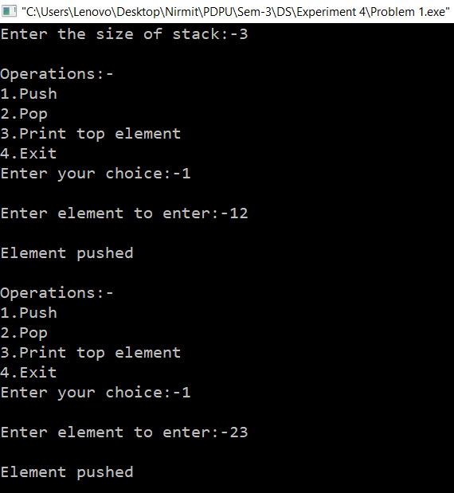
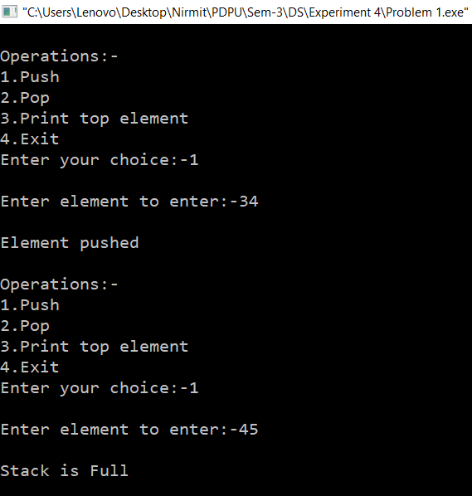
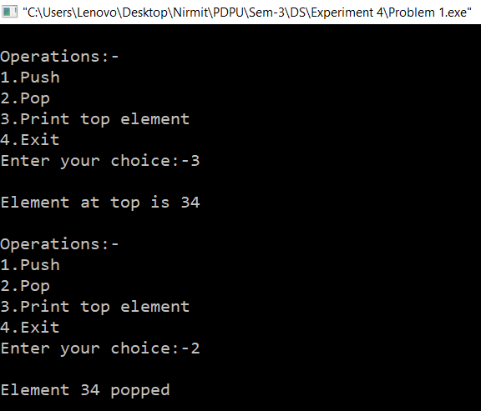
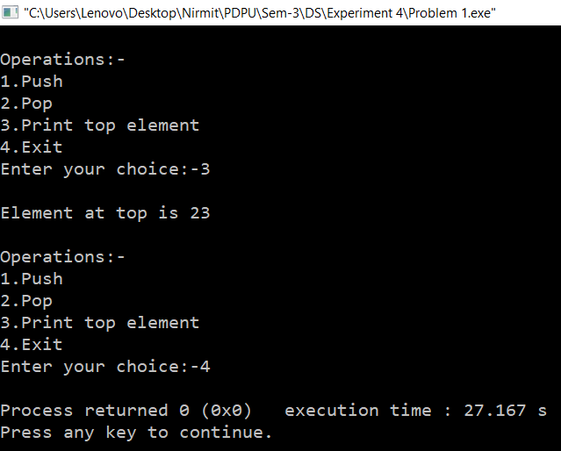
Time Complexity:- O(m) where m will be the number of times the operations will be performed till user enters 4.
Space Complexity:- O(n) where n is the user defined size of the stack.
Problem-2
Aim:- Given a stack, sort it using recursion. Use of any loop constructs like while, for, etc. is not allowed. We can only use the following functions on Stack S:
- isEmpty(S):- Tests whether stack is empty or not.
- push(S):- Adds new element to the stack.
- pop(S):- Removes top element from the stack.
- top(S):- Returns value of the top element.
Theory:- First we created a structure Stack in which we initialize size, top and array of pointer. Then we ask user the size of the stack. Then we dynamically allocate the size to the array. Then we make 5 user defined function isEmpty, push, pop and top. Here we called all the functions to implement push, pop and print top element.
Code:-
#include<stdio.h>
#include<stdlib.h>
struct Stack
{
int size,top;
int *array;
};
struct Stack *createStack(int size)
{
struct Stack *s=(struct Stack *)malloc(sizeof(struct Stack));
s->size=size;
s->top=-1;
s->array=(int *)malloc(sizeof(int)*size);
return s;
}
int isEmpty(struct Stack *s)
{
if (s->top==-1)
return 1;
else
return 0;
}
void push(struct Stack *s,int item)
{
if (s->top==s->size-1)
{
printf("\nStack is Full\n");
return;
}
else
{
s->top=s->top+1;
s->array[s->top]=item;
printf("\nElement %d is pushed\n",item);
}
}
void pop(struct Stack *s)
{
if (isEmpty(s))
{
printf("\nStack is Empty\n");
return;
}
else
{
printf("\nElement %d popped\n",s->array[s->top]);
s->top=s->top-1;
}
}
void top(struct Stack *s)
{
if (isEmpty(s))
{
printf("\nStack is empty\n");
return;
}
else
printf("\nElement at top is %d\n",s->array[s->top]);
}
int main()
{
int size;
printf("Enter the size of stack:-");
scanf("%d",&size);
struct Stack *s=createStack(size);
push(s,12);
push(s,23);
push(s,34);
push(s,45);
top(s);
pop(s);
top(s);
return 0;
}

Output:-
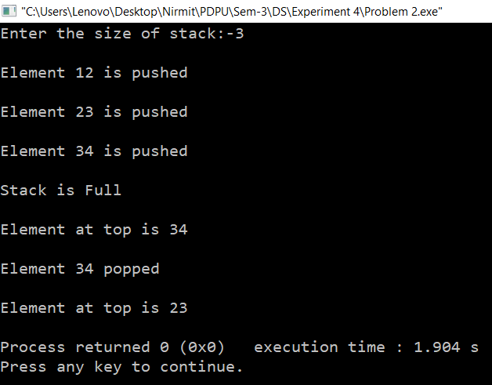
Time Complexity:- O(1) as no loop is there and no recursions is happening.
Space Complexity:- O(n) where n is the size of the array.

